Name:_______________________________ Date:_____________
Thanksgiving Day
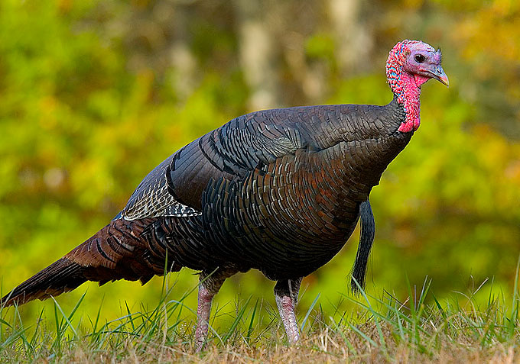
[cit. 2012-31-03]. Dostupný pod licencí Public domain na WWW:
<http://commons.wikimedia.org/wiki/File:Wild_turkey_eastern_us.jpg>
E Q Z X T U R K E Y N J T X W  Q E D I F M I H P S D V B E M  H N S D F Y N W O Z S E P O J  T P P J C T D S L Q V L E A G  U S V D V C I E Z C E W S R N  O R I E X H A T B Z W O S C H  M E N T D B N T F W V E J Q D  Y W X S Z C S L R T D O C P P  L O F A G B B E V M Z P Y P I  P L H O B U D R G T C D S N L  B F S R W J A S S M G W M Q G  Y Y K F O L K Z B S M F U W R  Z A C T E L V T L K P Z U I I  K M I T A R E T S B O L Z A M  G B X M Q Y E E D G O W G N F | TURKEY  ROASTED  PILGRIM  MAYFLOWER  EEL  LOBSTER  COD  PLYMOUTH  INDIANS  SETTLERS  DEER  FOWL

