# PŘÍLOHA Pracovní list: Obrázky

**Obrázek 1**

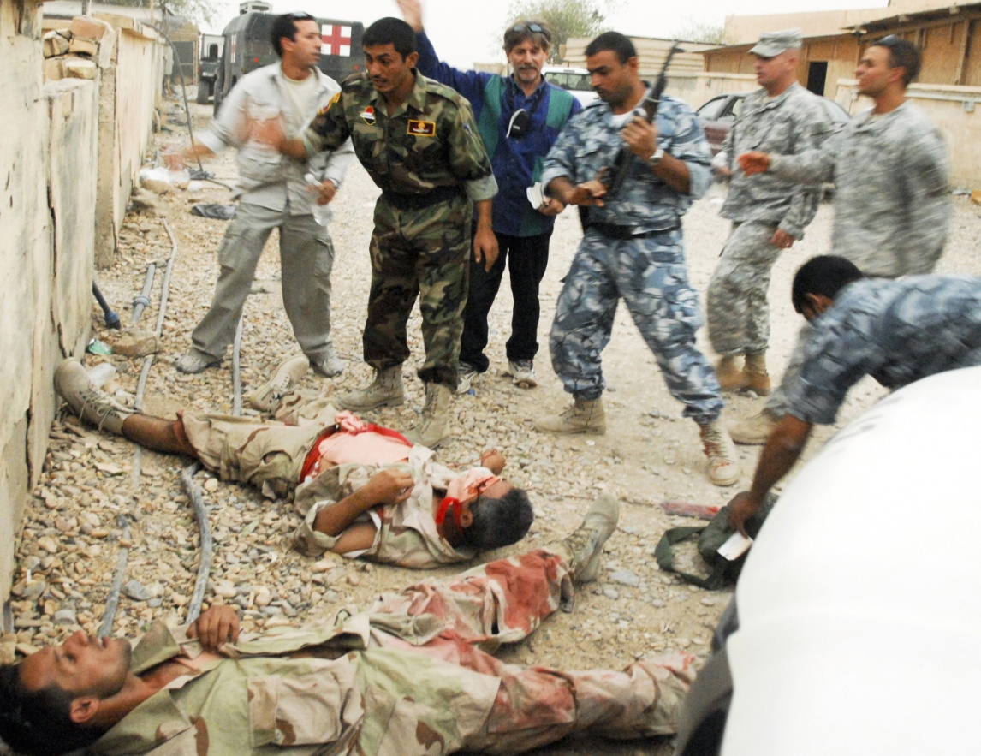

*Zdroj:* [*http://www.flickr.com/photos/soldiersmediacenter/1452244711/sizes/o/in/photostream/*](http://www.flickr.com/photos/soldiersmediacenter/1452244711/sizes/o/in/photostream/)

**Obrázek 2**

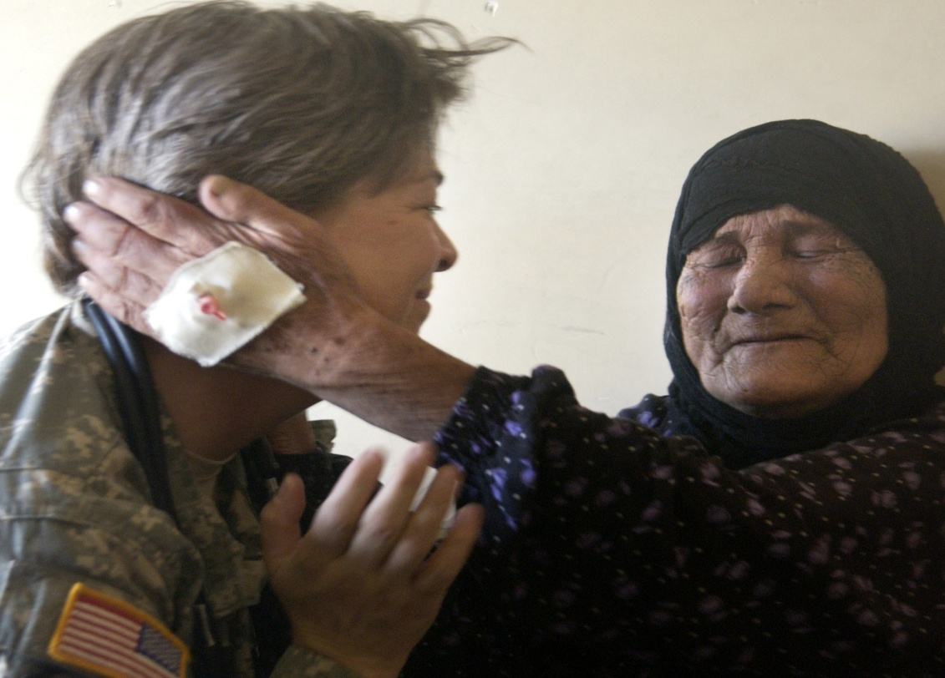

*Zdroj:* [*http://www.flickr.com/photos/soldiersmediacenter/738123890/sizes/o/in/photostream/*](http://www.flickr.com/photos/soldiersmediacenter/738123890/sizes/o/in/photostream/)

**Obrázek 3**

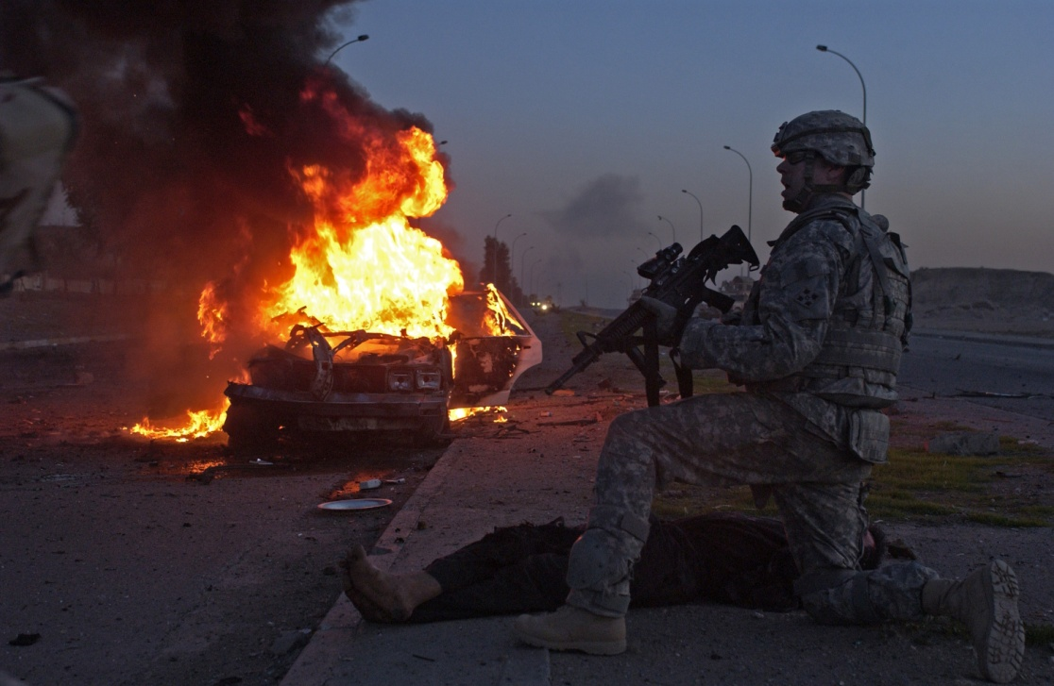

*Zdroj:* [*http://www.flickr.com/photos/soldiersmediacenter/2357605259/sizes/o/in/photostream/*](http://www.flickr.com/photos/soldiersmediacenter/2357605259/sizes/o/in/photostream/)

**Obrázek 4**

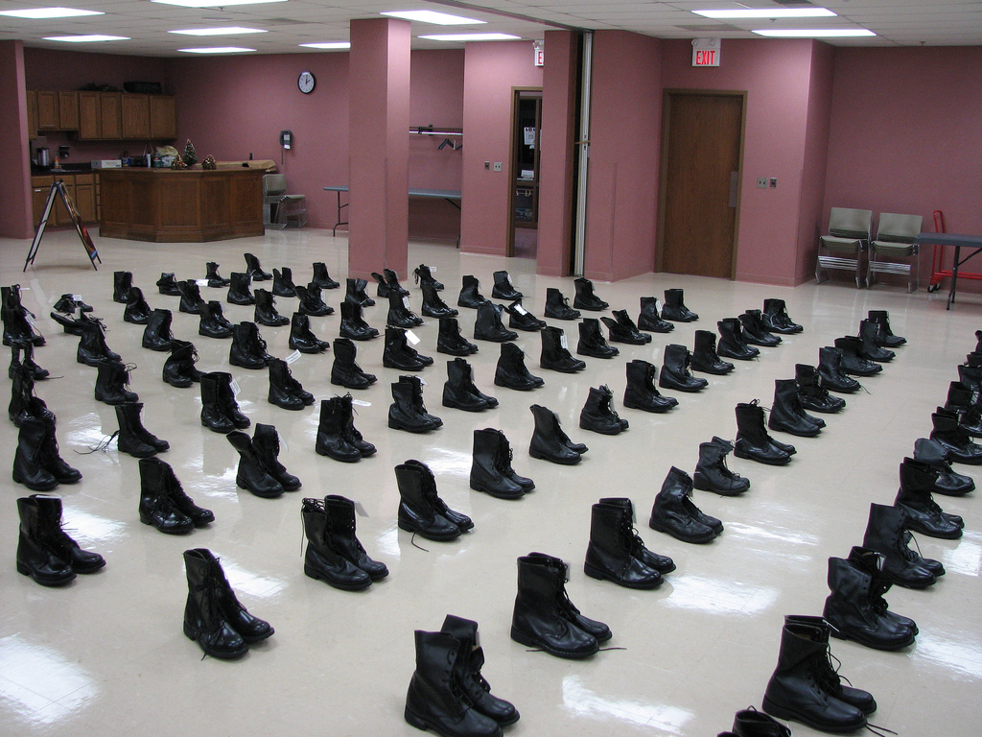

*Zdroj:*[*http://www.flickr.com/photos/soundfromwayout/312458142/sizes/l/in/photostream/*](http://www.flickr.com/photos/soundfromwayout/312458142/sizes/l/in/photostream/)