**Thanksgiving Day**

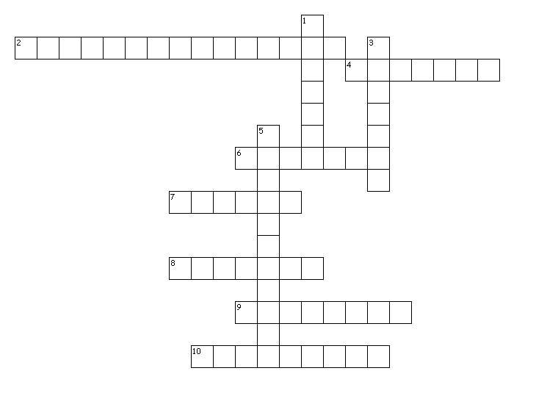

Across

2. great national holiday in the USA

4. the way the turkey is served on Thanksgiving

6. a newcomer

7. traditional food for Thanksgiving

8. original inhabitants in America

9. first settlers in America

10. a berry form which traditional sauce is made

Down

1. is done in the fields when plants have grown

3. fried vegetable connected with Thanksgiving

5. is held on Thanksgiving