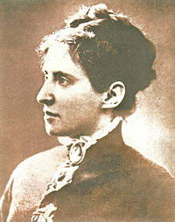

AUTHOR, UnknownUnknown. Wikimedia.org: Charlotta Garrigue [online]. 2010-07-11 [cit. 2019-01-09]. Dostupný pod licencí Public domain na WWW: <https://commons.wikimedia.org/wiki/File:Charlotta_Garrigue.jpg>.