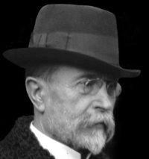

Josef. Wikimedia.org: Masaryk - detail [online]. 2009-01-04 [cit. 2019-01-09]. Dostupný pod licencí [Creative Commons Attribution-Share Alike 2.5](https://creativecommons.org/licenses/by-sa/2.5) na WWW: <https://commons.wikimedia.org/wiki/File:Masaryk_-_detail.png>.