**HISTORY CHARLES IV**

Charles IV was born in 1316. Charles was originally named Václav, after his grandfather. He was educated in France and he could speak five languages. He was an important person of the medieval Europe and became a king of Bohemia and Holy Roman emperor.

Charles IV loved Prague. Prague become the political, economic, and cultural centre and Charles IV founded Prague’s New Town. He also built many buildings in the city, for example Charles Bridge, Charles Square, part of the cathedral of Saint Vitus. He founded Charles University. It´s the oldest university in Central Europe. During his life he got married – not just once, but four times.

Charles IV is called “father of the country” in the Czech Republic.

**Answer the questions. You can work in small groups.**

1. Charles IV is called father of the country. Why?

2. What languages could Charles IV speak? What do you mean?

3. What do you know about architecture in medieval period?

4. What are the most typical buildings of this time?

5. What famous buildings were built by Charles IV? Find them on the map.

**Are the statements true or false?**

**Charles IV**

….was the eldest son of the king John of Luxembourg and the Queen Elisabeth.

….studied at Charles university.

…. was an excellent diplomat and a very good king.

….started many building projects.

Petr Parléř was his ministr.

During his reign started the Hussite wars.

**Complete the missing parts.**

1) ___________________is the oldest and largest university in the Czech Republic.

2) ___________________is a part of the New Town of Prague. It was known as *Dobytčí trh*

*3)* ___________________connects the Old Town and Lesser Town. It was called the Stone Bridge.

4)___________________was founded as a large area between Vyšehrad and the Old Town. It contains Wenceslas Square.

5)___________________was a place to store the royal treasures, collections of holy relics and the crown jewels.

**What can you say about each picture?**

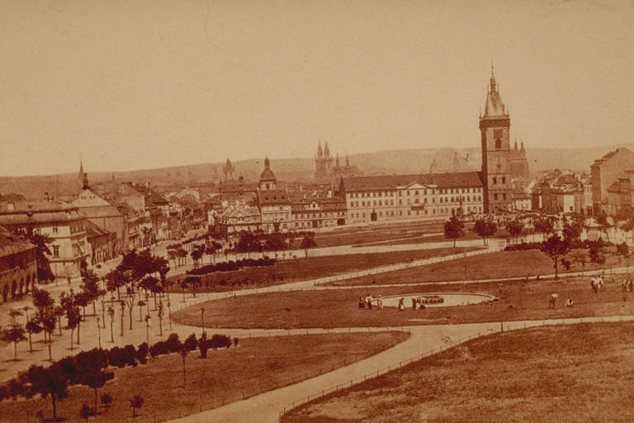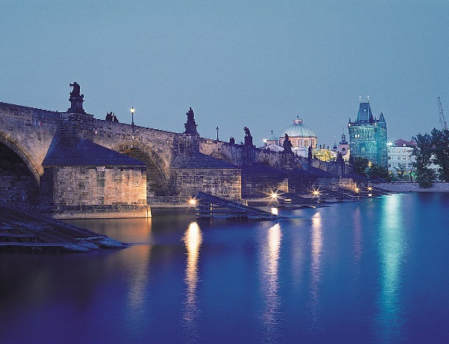

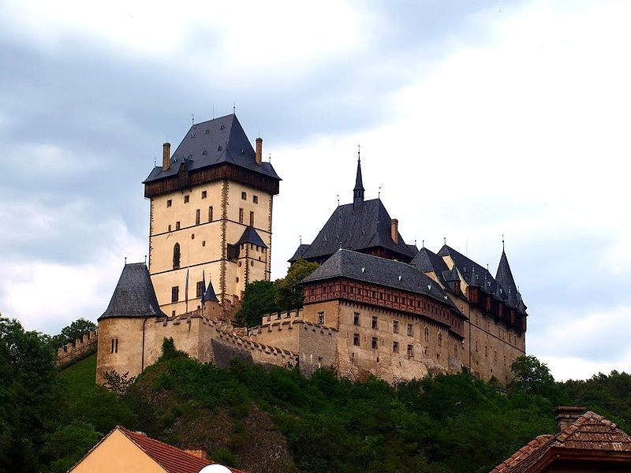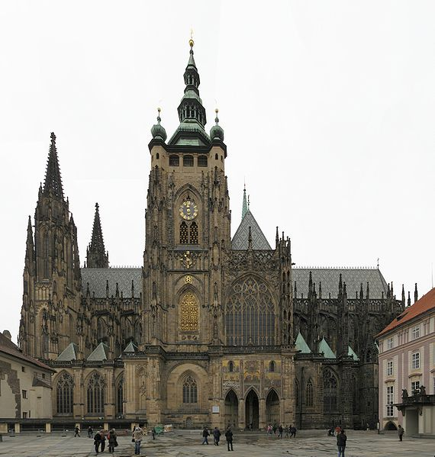

Otázky, které ti mohou pomoci:

**What?***(What is it? What do you know about? What is interesting there?)*

**Where?***(Where is it? Can you show it on the map?).*

**When?***(When was it built? When did you visit it?)*

**Why?***(Why is it famous? Would you like to visit it?)*

**Find the words.**

