

Worksheet 2: BODY PARTS

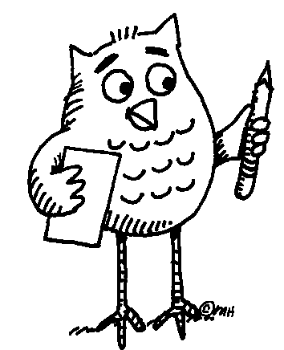 Task: Write down words that represent different parts of human hands and arms.
Make two columns:
English Your mother tongue 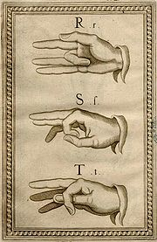
Manual alphabet (Bonet, 1620)
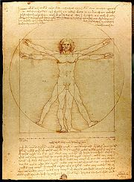

From: The Notebooks of Leonardo da Vinci (original edition 1883).

... Follow up activity for the whole class:
Can you teach your friends how to say the names of body parts in your language?
Notes for the teacher: Worksheet 2
Assessment: see above
Timing: 10 minutes (5 minutes for writing, 5 for checking and pronouncing the words in different languages)
Grouping: | ...
- Pairs of learners write down different parts of human hands and arms.
- After finishing they compare their answers with the rest of the class.
- Finally, the learners teach some of the words to the others in class in their own language.
Answer sheet
Hand: a thumb, fingers (index finger, middle finger, ring finger, little finger). Palm, wrist.
Arm: forearm, elbow, shoulder
Additional information: Some languages use only the word “finger” for all ten, whereas others differentiate between eight fingers and “a thumb”.
Follow up activity: Idioms related to body parts (presented or elicited by the teacher), e.g.
HEAD:
to head - to lead
to lose your head - to lose your presence of mind

EYE:
to make eyes at - to look lovingly at
to keep an eye on - to watch over

HAND:
to give a hand - to help
to take in hand - to take control of someone or something

FINGER:
all my fingers are thumbs - my hands are clumsy
to have a thing at one´s finger-tips - to know a thing thoroughly

SHOULDER:
to give the cold shoulder to someone - to ignore
to shoulder - to undertake

FOOT:
to foot the bill - to pay
to put your foot in it - to make a bad mistake

References: Worrall, A.J. English Idioms for Foreign Students. Longman 1970.

