This animal is big and grey. It has got four strong legs, big ears and a long trunk. It lives in Africa and Asia.

This animal is big and fat. It likes honey. It has got brown fur. It lives in Europe and Asia.

This animal is orange and black. It is very fast and strong. It has got sharp teeth. It lives in Asia.

This animal likes bananas. It swings through the trees. It lives in Africa.

This animal is very tall. It has got a long neck and four long legs. It is orange and brown. It lives in Africa.

This animal is striped. It is black and white. It eats grass. It lives in Africa.

a giraffe a zebra a tiger

a bear a monkey an elephant

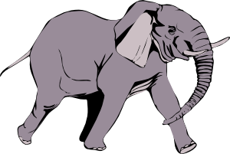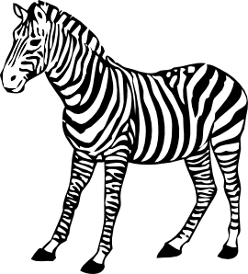
http://www.clker.com/clipart-3109.html http://www.clker.com/clipart-11751.html

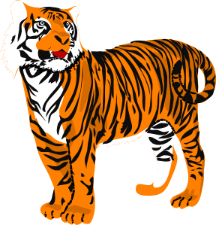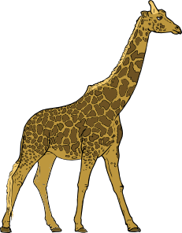

http://www.clker.com/clipart-6978.html http://www.clker.com/clipart-13976.html

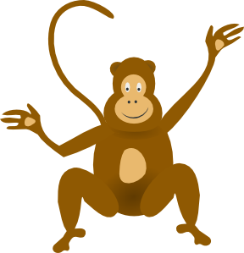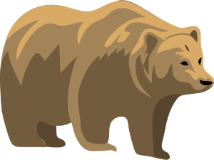
http://www.clker.com/clipart-24916.html http://www.clker.com/clipart-6967.html

A zebra is .......... – black and white.

A zebra eats..........

A zebra lives .......... ...........

A tiger is very fast and...........

A tiger has got .......... teeth.

A tiger is orange and...........

A monkey eats...........

A monkey .......... through the trees.

A monkey lives .......... ...........

A giraffe has got a long .......... and ...........
A giraffe is very ...........

A giraffe is orange and ...........

A bear likes ...........

A bear has got brown ...........

A bear is big and ...........

An elephant has got a long ...........

An elephant lives .......... .......... and ...........

An elephant has got four .......... legs.

Příloha D:

an elephant

lives in

is

grey
big
four strong legs
a long trunk

big ears

has got
Africa
Asia

