 | $$\frac{1}{1}$$ | 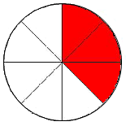 | $$\frac{3}{8}$$
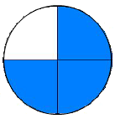 | $$\frac{3}{4}$$ | 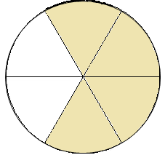 | $$\frac{4}{6}$$
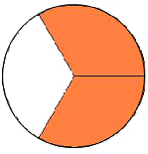 | $$\frac{2}{3}$$ | 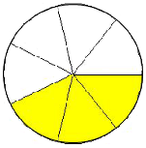 | $$\frac{3}{7}$$
 | $$\frac{1}{2}$$ | 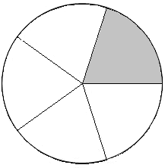 | $$\frac{1}{5}$$

