Vocabulary list
a castle – zámek a swimming pool – koupaliště

a church – kostel a hotel – hotel

a restaurant – restaurace a museum – muzeum

a car park – parkoviště a hospital – nemocnice

a train stop/train station – železniční zastávka a post office – pošta

GIVING DIRECTIONS

- Match the words with the map symbols./ Spoj obrázek se správným názvem.


Example: a swimming pool
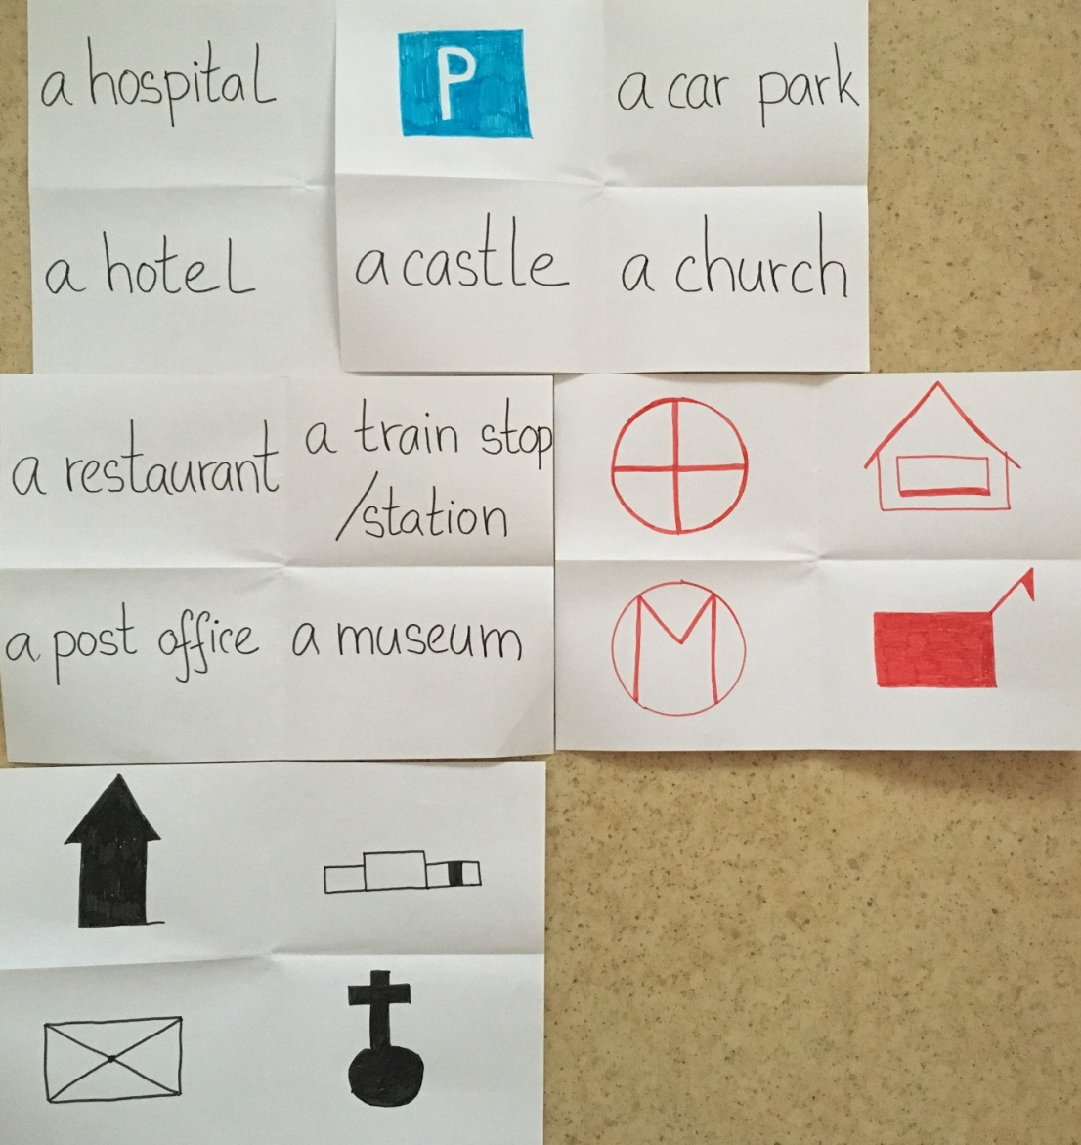

Vocabulary list - directions

Turn left
Go straight
Turn right
Crossroads
Go along

2. Draw the route. You can draw a small map./ Zaznamenej cestu. Nakresli si mapku jako vidiš v příkladu.

Example: | A: “Excuse me, where is the post office?”
 | B: “Go straight, turn right and go straight. Turn left and go straight. The post office is on the right.

Post office

A

Example: | A: “Excuse me, where is the bank?”
 | B: “Go along this street, then turn left at the crossroads and take the first street on the right
Example: | A: “Excuse me, where is the museum?”
 | B: “Go straight, turn left and go straight. Then turn right and go straight. Turn right and the museum is on the left side.

3. Can you see yourself in the map? Describe the way to the restaurant. /Vidíš, kde stojíš? Popiš cestu do restaurace.

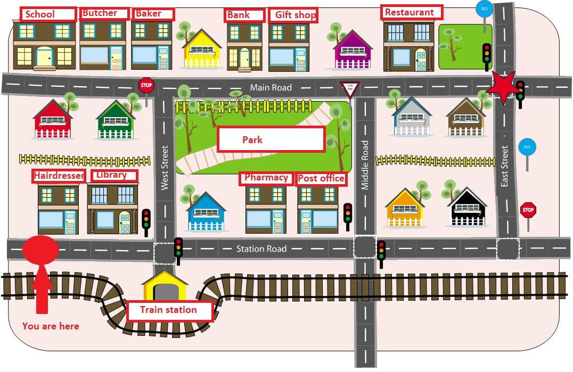

____________________________________________________________________________________________________________________________________________________________________________________________________________________________________________________________________________________________________________
4. Draw your map and three map symbols in it. Tell your friend some directions. He/she can draw a route. /Nakresli vlastní mapu. Vyber si tři mapové značky a zakresli je do své mapy. Vymysli cestu pro svého kamaráda. Zvládne ji zakreslit?

https://en.islcollective.com/resources/printables/worksheets_doc_docx/give_and_follow_directions_on_a_map/prepositions-giving-directions/50367

