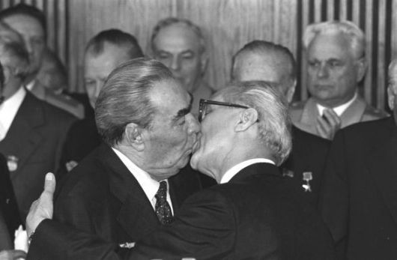

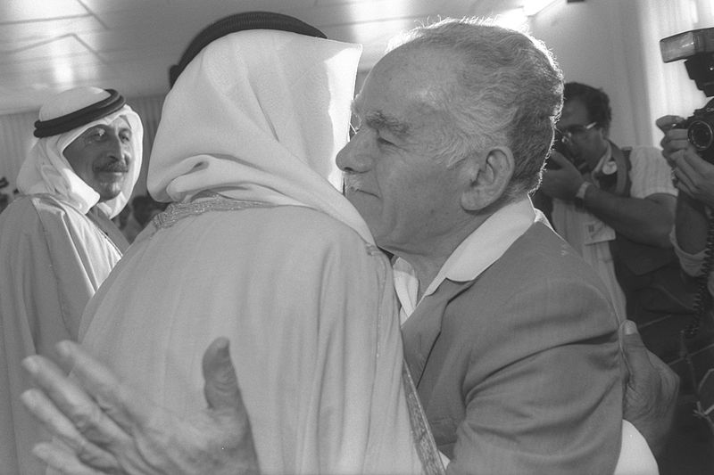

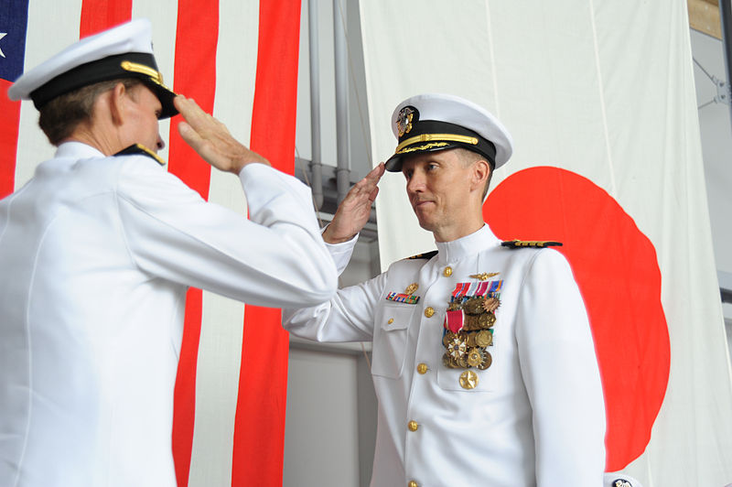

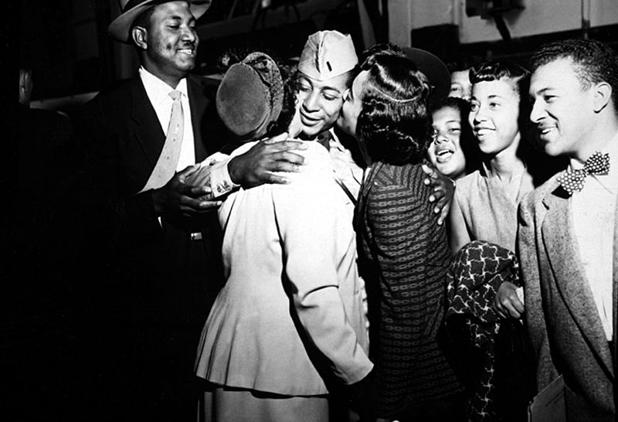

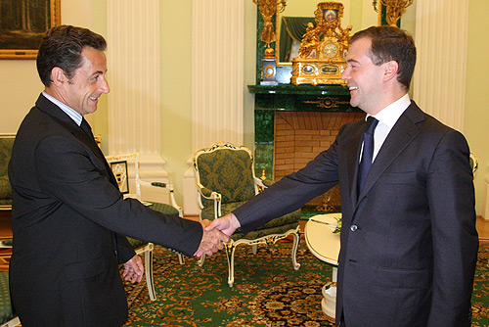

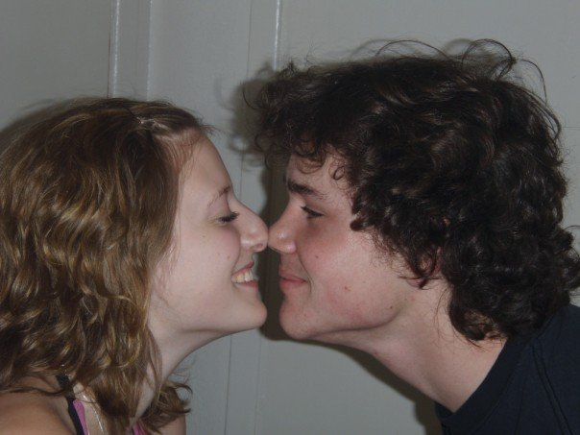

Citace – použité materiály

- BOSSU, Regis. Leonid Breznev kissing Erich Honecker, 1979 [cit. 2014-06-28]. Dostupný pod licencí fair use na WWW: http://en.wikipedia.org/wiki/File:Breznev-Honecker_1979.jpg

- MAGGI, Ayalon. P.M. Yitzhak shamir embracing sheikh aude abu-muammar, 1988. [cit. 2014-06-28]. Dostupný pod licencí Wikimedia Commons na WWW: http://commons.wikimedia.org/wiki/File:Flickr_-_Government_Press_Office_(GPO)_-_P.M._YITZHAK_SHAMIR_EMBRACING_SHEIKH_AUDE_ABU-MUAMMAR.jpg?uselang=cs

- BRADLEY, M. Matthew. NAVAL AIR FACILITY MISAWA, 2011. [cit. 2014-06-28]. Dostupný pod licencí Wikimedia Commons na WWW: http://commons.wikimedia.org/wiki/File:US_Navy_110708-N-KK192-489_Rear_Adm._Dan_Cloyd,_left,_commander_of_Naval_Forces_Japan,_salutes_Capt._James_Haugen.jpg?uselang=cs

- WEISS, Herb. 1st Lt. Alvin Anderson, one of the many repatriated POW's to return home aboard the USNS Marine Phoenix, embracing his mother and sister as other members of his family.1953. [cit. 2014-06-28]. Dostupný pod licencí Wikimedia Commons na WWW: http://commons.wikimedia.org/wiki/File:1st_Lt._Alvin_Anderson,_one_of_the_many_repatriated_POW%27s_to_return_home_aboard_the_USNS_Marine_Phoenix,_embracing_his_mother_and_sister_as_other_members_of_his_family_look_on_HD-SN-99-03179.jpg?uselang=cs

- [cit. 2014-06-26]. Dostupný pod licencí Creative Commons na WWW:
http://commons.wikimedia.org/wiki/File:Medvedev_meets_Sarkozy.jpg?uselang=cs

- [cit. 2014-06-26]. Dostupný pod licencí Creative Commons na WWW: http://commons.wikimedia.org/wiki/File:Eskimokiss.jpg?uselang=cs

