WORKSHEET 1 - THE CAKE RECIPE

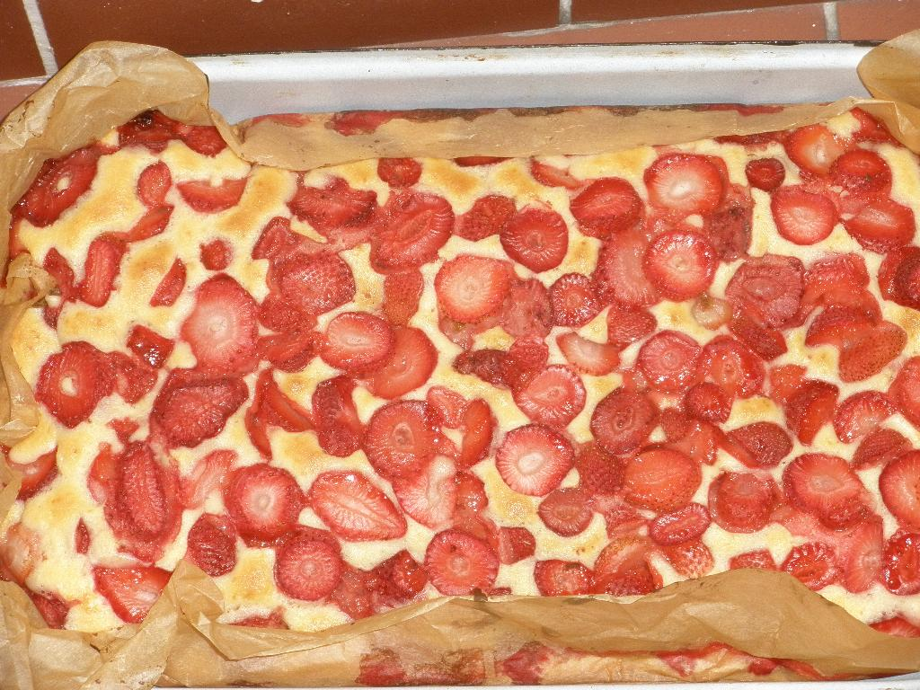
- You are in the kitchen now. Look at around and write down as many words as you see or know.
Do not use the dictionary.

- Each group has different cards with the names of the kitchen equipment (vybavení). Can you find the object in the kitchen and stick (nalepit) the card on it, please. If you don´t know the word´s meaning or pronunciation, use the dictionary.

- Walk around and read the words, if you don´t know their meaning or pronunciation, write them on the whiteboard.

- Now you are able to say the kitchen equipment in English. If not, look around you, the cards will help you.
Let´s look at the food you bought. Can you write down the English words?

FOOD STUFF:

- LISTENING:
- Listen and write down the ingredients you didn´t buy.

- Listen again and write down (in question no. 4) the amount of each ingredient. (amount = quantity = how much)

- GRAMMAR

We write | We say
cup tea | cup of tea
200 g sugar | two hundred grams of sugar
1 tablespoon oil | one tablespoon of oil
slice bread | slice of bread
glass water | glass of water

Now read how much of each ingredient we need for our cake.

- PREPARATION (PŘÍPRAVA)

Go to your kitchen unit (kuchyňská linka) and prepare all the ingredients (and their amount) you will need.
If you are ready, change the place with the other group and check (zkontroluj) their preparation.

WORKSHEET 2 - HOW TO CHANGE THE INGREDIENTS TO A CAKE
- Read the instructions and underline (podtrhni) the verbs you do not understand.
What does the English word „verb“ mean?
(Look at the text below.)

Instructions:

- Put the eggs, sugar and the oil into the bowl.
- Mix it with the mixer.
- Add the flour, a packet of baking powder and two cups of milk to the mixture.
- Mix it with the mixer till you have the „batter“ (těsto).
- Put the baking paper on the tray.
- Pour the „batter“ into the tray.
- Wash the strawberries and slice them.
- Put the sliced strawberries on the dough (těsto).
- Put the tray into the oven for 30 minutes, 180 °.
- When the cake is ready, sprinkle (cover) it with powdered sugar.

- Look at the whiteboard. Can you find the Czech equivalent to the English verb?
You can use the dictionary.

- Now read the instructions again and be sure you understand what to do.
If you understand, LET´S DO IT!
If you don´t understand, ask the other groups and then the teacher.

DURING THE BAKING

!!Read the next three tasks. You can do the first and second one with your partner or your group. The third one you will do individually and the outcome (výsledek) you will give to you teacher for your evaluation (hodnocení). So be sure, you have time for doing the third task!!
- Do the washing up, clean your kitchen unit.
- Play the cards (domino, matching) to revise new english words and grammar.
- Ask for the worhsheet no. 3 and do the exercise individualy (alone, only you).

WORKSHEET 3A - REVISION
Can you write down the recipe of strawberry cake? The pictures here and the words around the kitchen help you.

- the ingredients:

the amount |  | Ingredients
4
1,5 |  | SUGAR
2
1 | PACKET
8
4 | -
1 | KG

- Write down the instructions. Use these cues to help you:

Put the ........, ........ and the ...... into the ....(1)
Mix it with the .............
Add the ......., a packet of ......... and two .... of ..... (2) to the mixture.
Mix it with the mixer till you have the ...... (3)
Put the baking ........... on the ....... (4)
Pour the batter into the ........
Wash the ....... and ...... (5) them.
Put the sliced ........... on the dough.
Put the tray into ........... for ....... minutes, 80°.
When the cake is ready, ..........it with powdered ........

1
2
3
4
Name: worksheet 3A

- Ingredients: | 2. Instructions:

WORKSHEET 3B - REVISION

Do you remember the recipe of strawberry cake? The pictures here and the words around you will help you.

- the ingredients:
4
1,5
2
1 | PACKET
8 |  | SUGAR
4 | -
1 | KG

Name: Worksheet 3B

1. Ingredients:

- Number the instructions in the correct order

Put the tray into the oven for 30 minutes, 180°.
Add the flour, a packet of baking powder and two cups of milk to the mixture.
When the cake is ready, sprinkle (cover) it with powdered sugar.
Put the baking paper on the tray.
Put the sliced strawberries on the dough.
Pour the „batter“ into the tray.
Mix it with the mixer till you have the „batter“.
Put the eggs, sugar and the oil into the bowl.
Wash the strawberries and slice them.
Mix it with the mixer.

WORKSHEET 4 - EVALUATION

- Set the table and enjoy your strawberry cake.
- In pairs or in a small group compare your worksheets no. 3 and try to correct them.
- Fill the questionnaire (dotazník).

Self-assessment questionnaire
Posuďte, jak jste splnili následující body, a ohodnoťte se „SMAJLÍKAMA“.

JMÉNO: |  |  | 
Používal/a jsem základní kuchyňské vybavení bez potíží samostatně a bezpečně.
Dohodl/a jsem se na své roli ve skupině a zorganizoval/a jsem si svoji práci.
Podle poslechu jsem v rámci skupiny vytvořil/a seznam surovin a jejich množství.
Z anglicky napsaného receptu správně přečtu množství dané suroviny.
Připravil/a jsem pokrm dle anglického pracovního postupu.
Dodržel/a jsem základní principy stolování a společenského chování.
Vyřešil/a jsem pracovní list č. 3.
Hodina vaření v anglickém jazyce mne bavila.

