Which three pens have made the mysterious spot?

- EQUIPMENT

1a. Match the pictures to the words:

a cup or a beaker
scissors
a skewer
a piece of filter paper
a paper clip
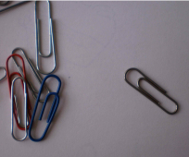
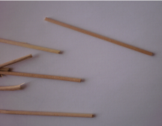

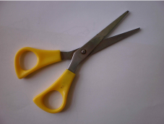
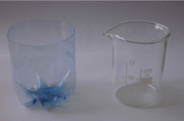

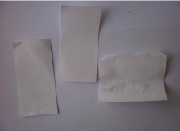

1b. Your teacher used 3 different pens or markers to make one dark spot.

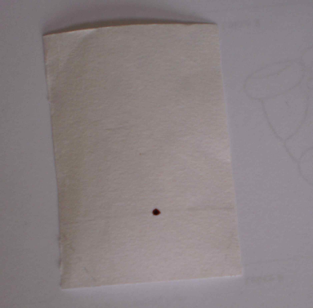

Look at the spot on your filter paper, look at the pens – they are numbered. Guess which 3 pens have made the spot. Write your guess.

I guess the spot is made by the pens number _____, _____ , and _________.

Now you are going to discover the truth. How? You can use paper chromatography.

- Look at these photographs. Try to describe them.

a)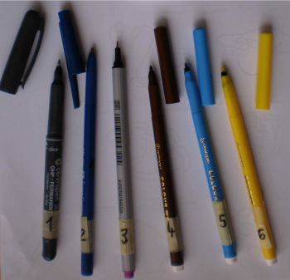

______________________________________

b)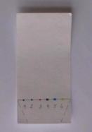

______________________________________

c)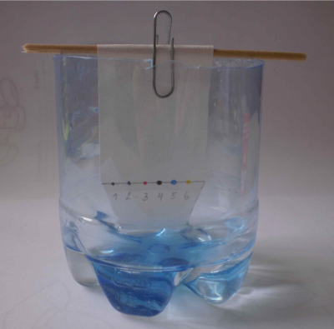 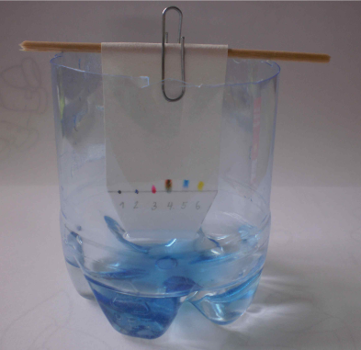 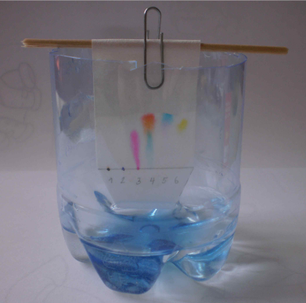

___________________________ _____________________ ______________________

3. EXPERIMENT

3a. Write your hypothesis. How can you discover which 3 pens have made the mysterious spot?

Hypothesis: ______________________________________________________________________________________________________________________________________________________

3b. Discuss your hypothesis with your partner.

Hypothesis of your pair: ______________________________________________________________________________________________________________________________________________________

3c. Do your experiments

How to move your spots?
Put a few water into your cup. Take the filter paper with the mysterious spot and make other spots with the numbered pens on the same line. The spots must be very small. Under these spots write their numbers with a pencil. Cut off the corners of the filter paper. Fasten the filter paper on a skewer with a paper clip as you can see in the photographs.
Be careful: At the beginning all the spots must be above the water level. The paper must only touch the water level.

3d. Write your results. Write a report in past simple:
____________________________________________________________________________________________________________________________________________________________________________________________________________________________________________________________________________________________________________

Conclusions:
We discovered that our teacher used pens number ____, ____ , and __________________, because _________________________________________________________________________________________________________________________________________________________________________________________________________________________________

Picture:
You can stick your dry chromatogram here:

3e. Tidy up your working place.
3f. Discuss your results with other groups.
4. Sebehodnocení

Dokonči věty:

Dnes se mi podařilo ___________________________________________________________

K vyřešení úkolu jsem přispěl tím, že _____________________________________________

Chci ocenit svého spolužáka za ______________________________________________________________________________________________________________________________________________________

Kritéria hodnocení:

Protokol je kompletní a úhledný.
Všechna práce včetně úklidu je dokončena a odevzdána včas a bez připomínání.
Tvrzení jsou logicky vystavěna na výsledcích pokusu.
Oba členové dvojice se aktivně zapojovali po celou dobu, včetně částí vedených v AJ.

VOCABULARY HELP
mysterious – tajemný
a spot – tečka, skvrna
a marker – fixa
a beaker – kádinka
a skewer – špejle
guess – odhad
a liquid – kapalina
water level – vodní hladina
to discover – objevit
a result – výsledek
a procedure – postup
different – různý, odlišný
to fasten – připnout

THEORY HELP
PAPER CHROMATOGRAPHY:
Different colours move differently on the paper.
How can a spot move?
It can be moved by a liquid – today you’re using water.
Some colours move fast, some colours move slowly, some don’t move.
Proč to funguje: Kapalina se po papíře pohybuje (vzlíná), čím více se barvivo rozpouští ve vodě, tím více se s ní pohybuje. Když se barvivo rozpouští ve vodě méně, drží se papíru, a pohybuje se tedy pomaleji.

