Příloha 2 – Steckbrief - Orangenbaum

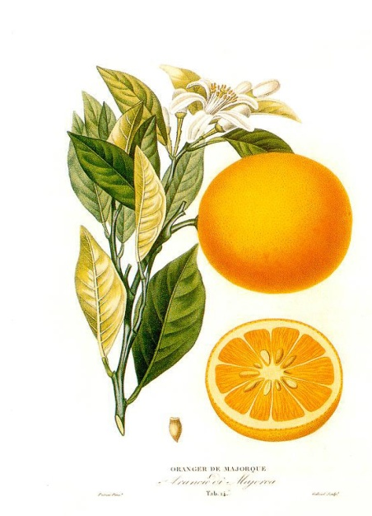
STECKBRIEF - ORANGENBAUM

Frucht: _________________________________
Form: ________________________________________________________________________________
Farbe:__________________________________________________________________________
Produkte (wozu verarbeitet?):_______________________________________________________
________________________________________________________________________________
Haupterntezeit:___________________________________________________________________
Das wichtigste Anbauland:___________________________________________________________

Pflanze: _________________________________
Familie:____________________________________________________________________________
Gestalt:____________________________________________________________________________
Blatt:______________________________________________________________________________
Blüte:______________________________________________________________________________
Sorten:_____________________________________________________________________________

