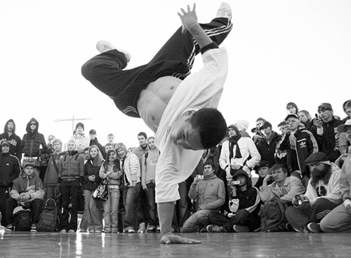

ZABARA, Alexander. A b-boy performing at Street Summit 2006 in Moscow. 2007. [cit. 2013-11-13]. Dostupné z: http://commons.wikimedia.org/wiki/File:Moscowcipher.jpg

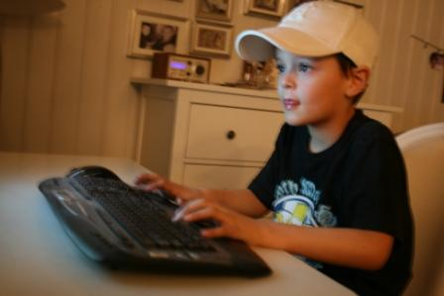

RAVN, Marisa. Kid playing on computer. 2009. [cit. 2013-11-13]. Dostupné z: http://commons.wikimedia.org/wiki/File:Spilling.jpg?uselang=cs

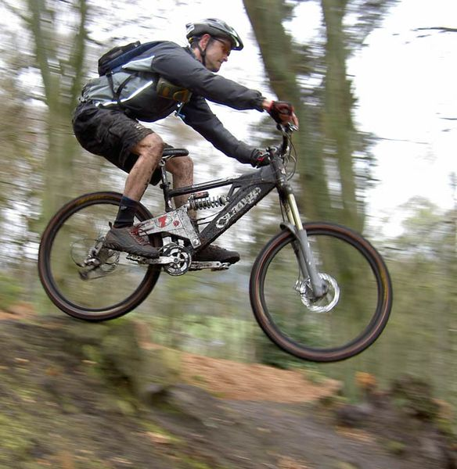

ARMSTRONG, Andy. Mountain biker jumping. Rothbury, Northumberland, UK, 2010. [cit. 2013-11-13]. Dostupné z: http://commons.wikimedia.org/wiki/File:Mountain-bike-jump.jpg

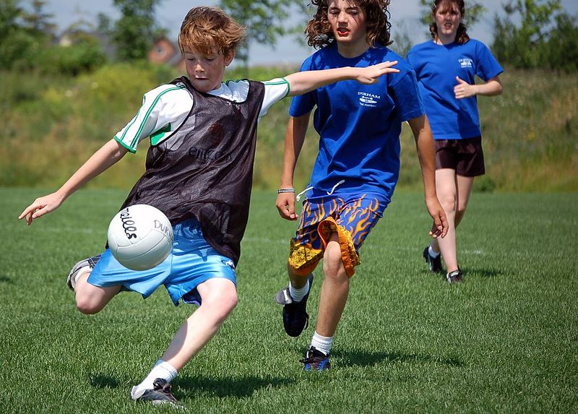

MEALIFFE, Derrick. Children playing Gaelic football. Canada, 2006. [cit. 2013-11-13]. Dostupné z: http://commons.wikimedia.org/wiki/File:Children_playing_Gaelic_football_Ajax_Ontario.jpg?uselang=cs

