Příloha č. 1

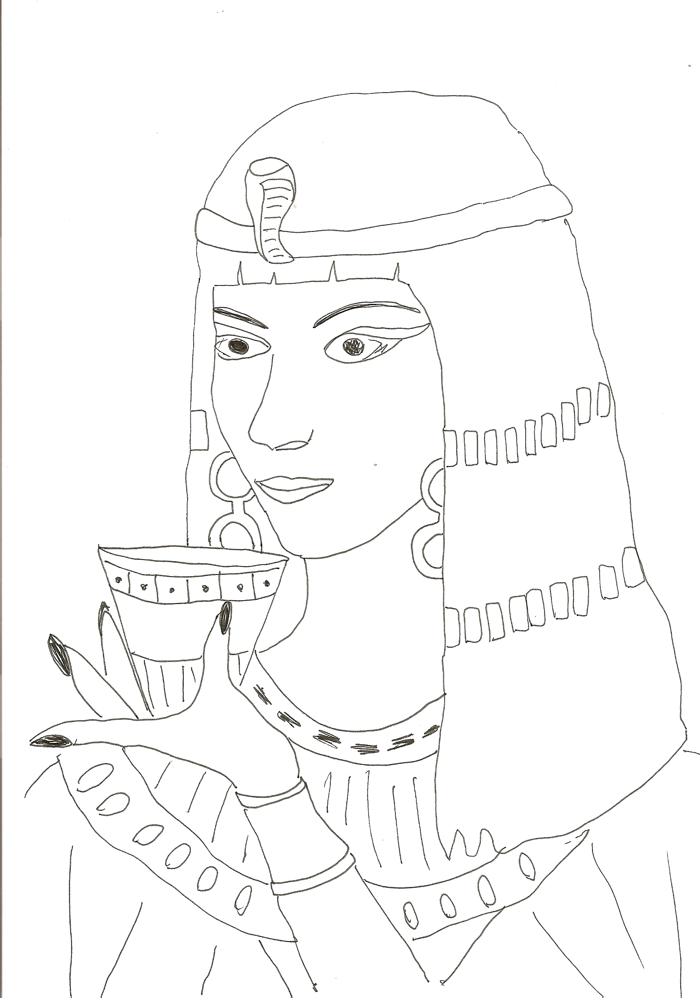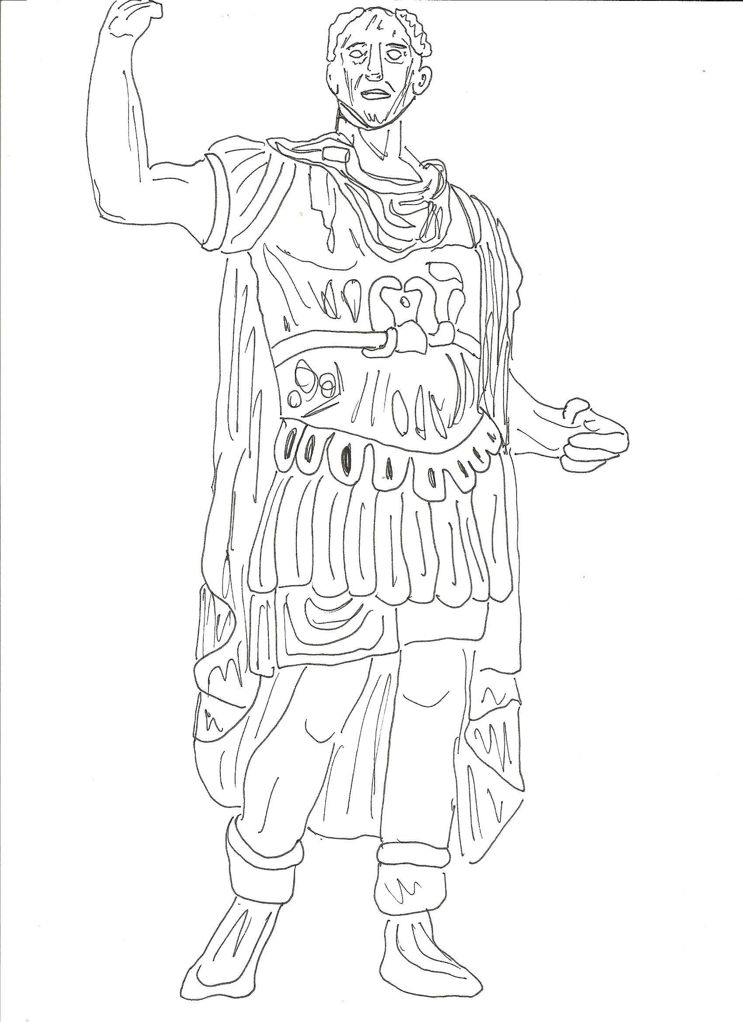

Příloha č. 2

JOIN
ARMY
APPOINT
CIVIL
WAR
LEADER
ENEMY
MASTER
EXPEDITION
SERVE
VICTORY

Příloha č. 3

Paragraph ___
Julius Caesar was a great general and an important leader in ancient Rome. He was a brilliant general who won many victories for Rome.
Paragraph ___
Julius Caesar was born in Rome on 13 July 100 BC. He was born in a patrician family. When Caesar was 16, his father died. Later Caesar left Rome and joined army.
Paragraph ___
In 60–61, he served as governor of the Roman province of Spain. In 60 BC, he was a member of First Triumvirate – a pact with Pompey and Crassus, they helped him to become a consul in 59.
Paragraph ___
Then he was in Roman Gaul where he stayed for 8 years. He connected the whole France and Belgium to the Roman Empire. He made two expeditions to Britain, in 55 and 54 BC.
Paragraph ___
Julius Caesar crossed the Rubicon in 49 BC. The civil war started. He returned to Italy, Pompey left Italy. Caesar was appointed dictator. When Caesar got to Egypt, Pompey was dead. Caesar met Cleopatra (the Egyptian queen) and took her back to Rome with him. They had a child, Caesarion.
Paragraph ___
Caesar was now the master of Rome and made himself dictator and consul. He started with many reforms. Julius Caesar became more popular with the people. He had many enemies. On 15 March 44 BC, he was killed by Brutus and Cassius. Brutus was Caesar´s friend or his son.

Příloha č. 4

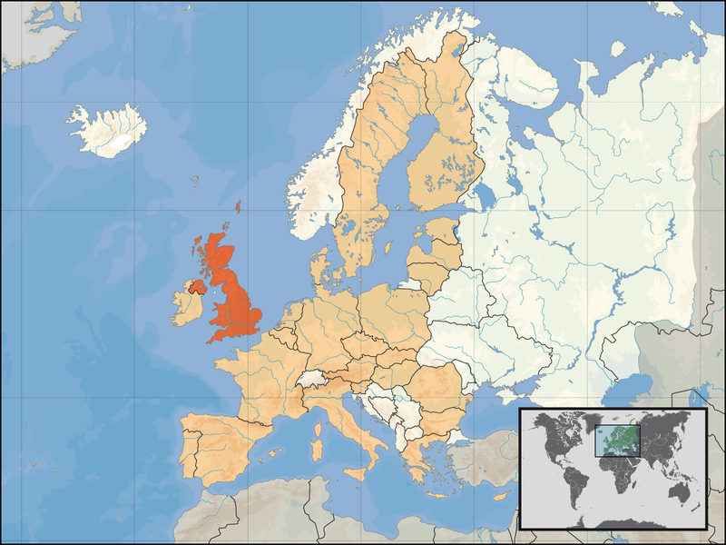

Příloha č. 5

- Caesar became consul. | - 49 BC
- Caesar was killed. | - 100 BC
- Caesar crossed the Rubicon. | - 44 BC
- Caesar was born. | - 55 and 54 BC
- Caesar made expeditions to Britain. | - 59 BC

- Caesar became consul. | - 49 BC
- Caesar was killed. | - 100 BC
- Caesar crossed the Rubicon. | - 44 BC
- Caesar was born. | - 55 and 54 BC
- Caesar made expeditions to Britain. | - 59 BC

- Caesar became consul. | - 49 BC
- Caesar was killed. | - 100 BC
- Caesar crossed the Rubicon. | - 44 BC
- Caesar was born. | - 55 and 54 BC
- Caesar made expeditions to Britain. | - 59 BC

- Caesar became consul. | - 49 BC
- Caesar was killed. | - 100 BC
- Caesar crossed the Rubicon. | - 44 BC
- Caesar was born. | - 55 and 54 BC
- Caesar made expeditions to Britain. | - 59 BC

Příloha č. 6

Self-reflection | Ano | Částečně | Jen něco | Ne
Vyhledám v cizojazyčném textu názvy zemí a zakreslím je do mapy na odpovídající místa.
Znám alespoň 5 nových slovíček z dané oblasti.
Dokážu sdělit 5 informací o Caesarovi v angličtině, 10 v češtině.
Vyhledám samostatně v textu požadované informace.
Naslouchal jsem ostatním, když jsme pracovali ve skupině.
Ocenil jsem práci ostatních.
Ve skupině jsme si poradili, když bylo potřeba.

Self-reflection | Ano | Částečně | Jen něco | Ne
Vyhledám v cizojazyčném textu názvy zemí a zakreslím je do mapy na odpovídající místa.
Znám alespoň 5 nových slovíček z dané oblasti.
Dokážu sdělit 5 informací o Caesarovi v angličtině, 10 v češtině.
Vyhledám samostatně v textu požadované informace.
Naslouchal jsem ostatním, když jsme pracovali ve skupině.
Ocenil jsem práci ostatních.
Ve skupině jsme si poradili, když bylo potřeba.

