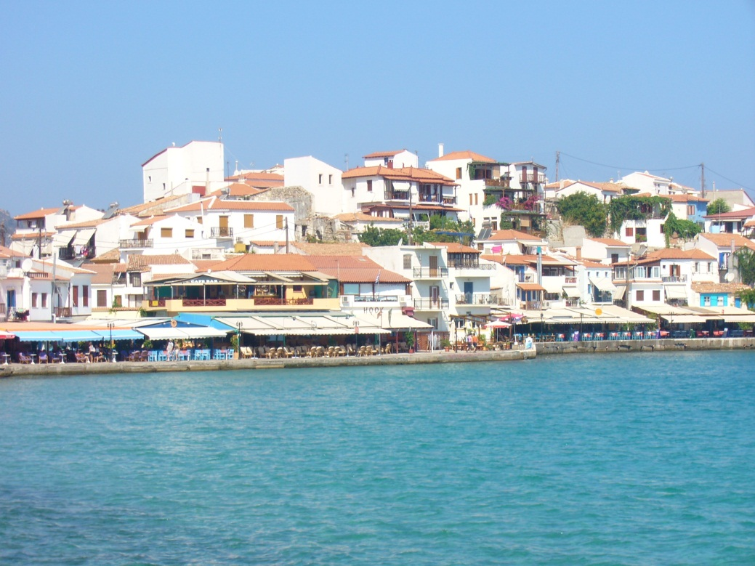

Autor: Pavla Smolová
  holiday
  Dear Mrs Pavla Smolova.Here we are on Holiday.In the Croatia.Here is beautiful.See you soon. Julie Stodolova
  FROM:
  Julie Stodolova
  julik13@centrum.cz
  TO:
  Pavla Smolova
  pavlasmolova@spoluzaci.cz

