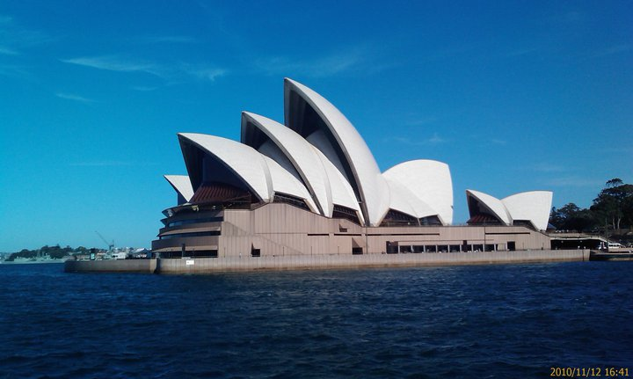

Autor: Pavla Smolová
  Hello My Friend
  Hello! I am Sydney today. It is very beautiful city. Is here hot. How are you? I am happy. In Sydney are a lot people. It is very very very very beautiful city. There are a lot cars. My mum and dad are great.
  Hope you are fine.
  Aneta
  FROM:
  Vacková aneta
  aneta.mona3@seznam.cz
  TO:
  Smolová Pavla
  pavlasmolova@spoluzaci.cz

