Thanksgiving Day

Group 1:
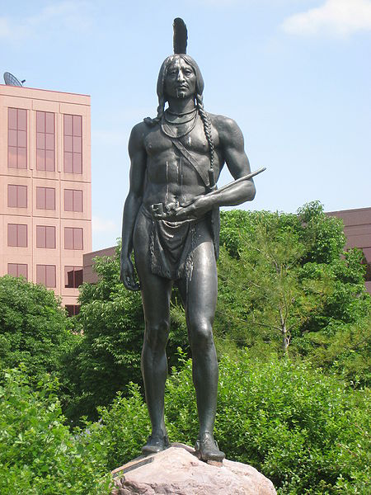
[cit. 2012-03-13]. Dostupný pod licencí Public domain na WWW: <http://commons.wikimedia.org/wiki/File:Massasoit,_KC_MO_-_general_view.JPG>

Who were pilgrims? Why did they come to America?

Group 2:
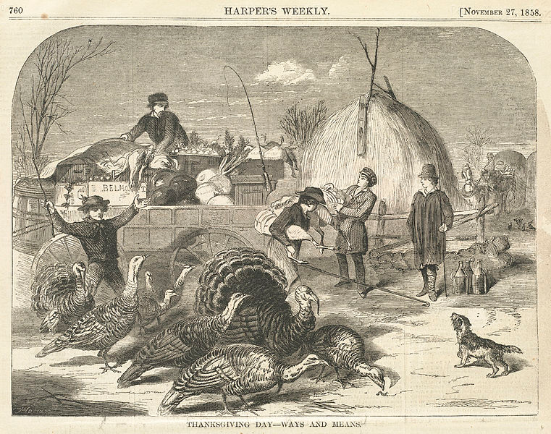
[cit. 2012-03-31]. Dostupný pod licencí Public domain na WWW: <http://commons.wikimedia.org/wiki/File:Thanksgiving_Day_--_Ways_and_means_%28Boston_Public_Library%29.jpg>

Who helped the first settlers? How did they celebrate the 1st Thanksgiving?

Group 3:
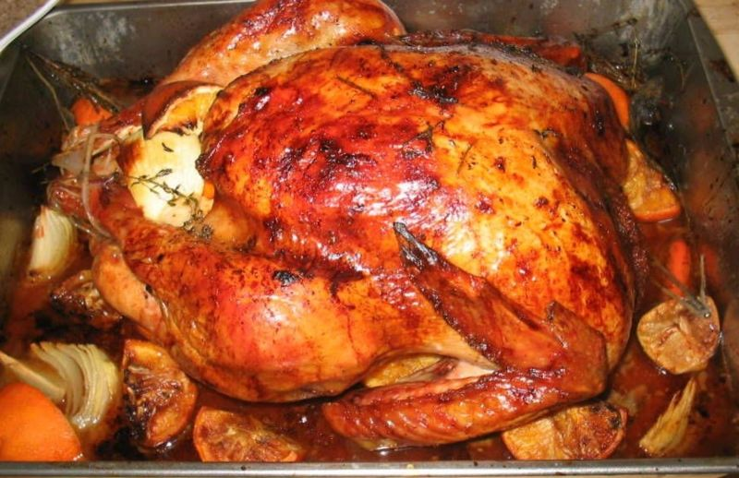
TheKohser. [cit. 2012-03-31]. Dostupný pod licencí Creative Commons na WWW: <http://commons.wikimedia.org/wiki/File:Oven_roasted_brine-soaked_turkey.jpg>

How is Thanksgiving Day celebrated today?

